Linux commands part 2

1.Elevate your user access to root;

First I use the [whoami command](https://www.cyberciti.biz/faq/unix-linux-whoami-command-examples-syntax-usage/" \o "Linux / Unix: whoami Command Examples) to verify user identity. Next command is sudo –s and we enter the password from our user account

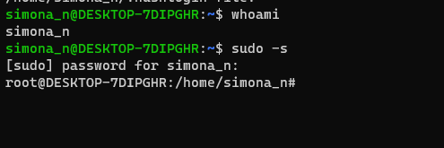

*Other commands for changing user access to root*: $sudo –i or sudo su -

#exit -if we no longer want to have access root

2.add a new user to your Linux OS and set a password for it;

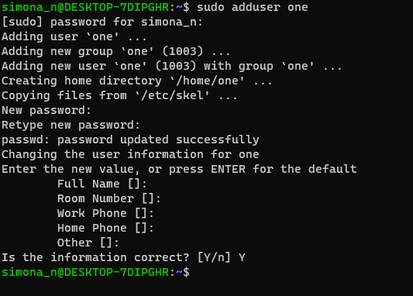

We exit from root access then we add new user

root user who has all permissions- sudo bash(to switch to another user: su imeNaUser)

delete user: sudo userdel imeNaUser

1. Use su plus the name of the user you just added to log on.
2. "Exit" to log out.

3.Test if you can log in using that user;

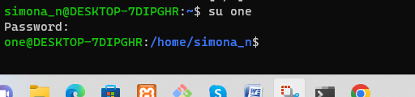

to switch to another user: su imeNaUser

4.Using grep command check if the user is created;

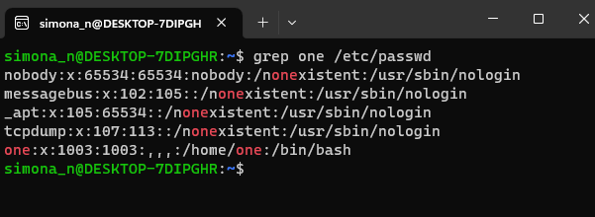

***The*[grep](https://www.baeldung.com/linux/common-text-search)*command searches in the*/etc/passwd *file for lines containing a match to the word*one.**

*$ id one –another command to check if user exists*

5.grep the UID of each user;

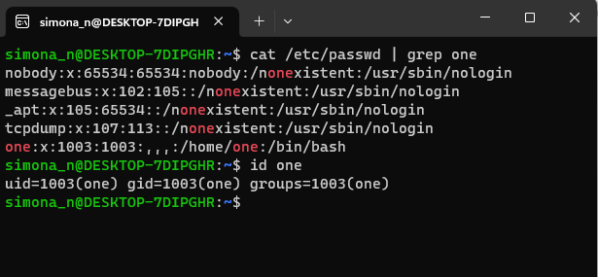

The uid is 1003

6.Find out the GID of the created user;



7.Change the password of the user and force it to change the pass on his next login;

to force a user to change his/her password, first of all the password must have expired and to cause a user’s password to expire

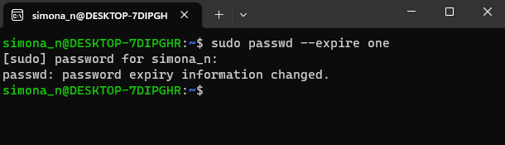

verify the user **one’s** password expiration and aging information

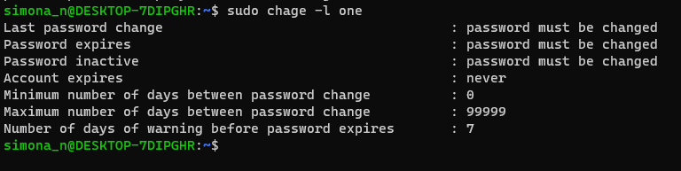

Once the user **one** tries to login next time, he will be prompted to change his password before he can access a shell

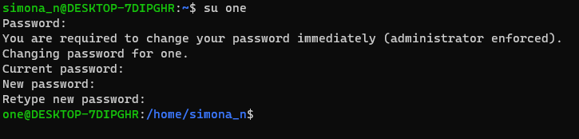

8.Add a new user and set an expiration date for it, with a five-day warning period;

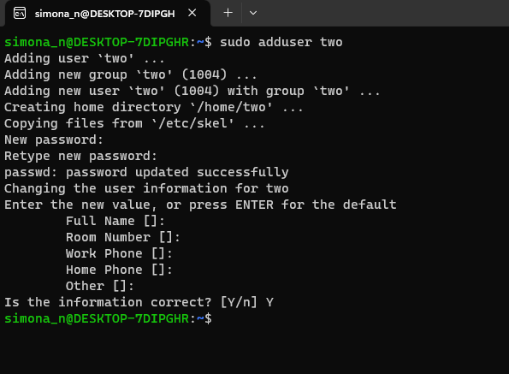

- To verify the user account expiration details we can use **chage** command

sudo chage -l Test

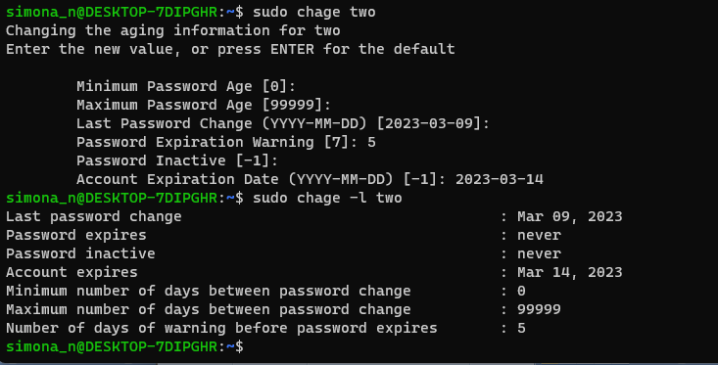

9.Create a new group;

*So I didn’t see that later we need to create group with name “group1” and I accidentally named this group “group1”

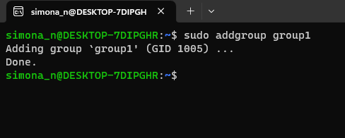

10.Assign the two new users to that group;

-to change a user’s primary group, we can use the -g flag

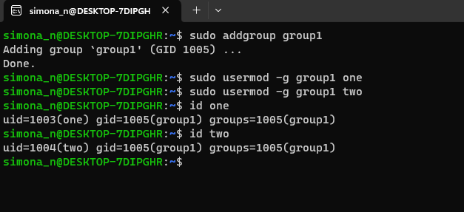

11.Lock one of the user accounts;

**Check if the user account is locked.**  
Check for the flag **\*L\*** in the below command output which indicates that the account is locked.

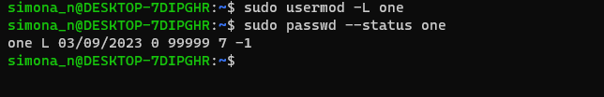

For unlocking the user account: sudo usermod -U one

12.Change the shell of one user to tcsh;

First list all available shells on your Linux system, type.

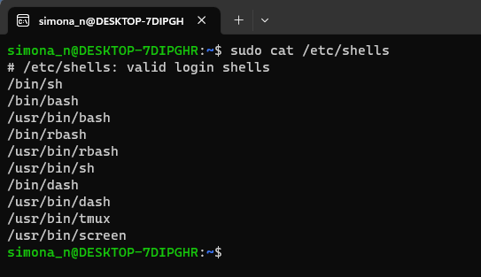

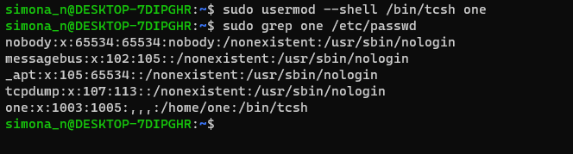

13.Make sure your home directory has “execute”access enabled for group and other.

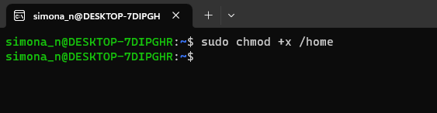

14.Change to your home directory, and create a directory called labs;

cd takes you back to your home directory

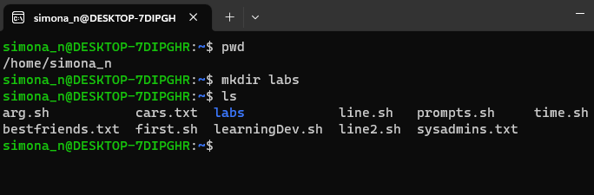

15.Create an empty file in labs directory

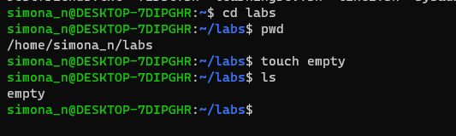

-Verify that file has been created with the ls

16.Change permissions of file to rwx-rwx-rwx

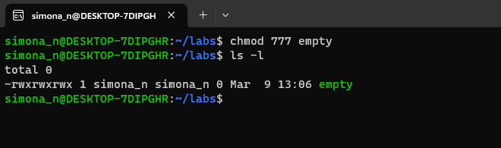

17.List the file. What color is the file?



It’s green.

18.Change the permissions back to rx-rw-rw

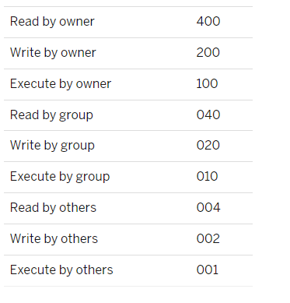

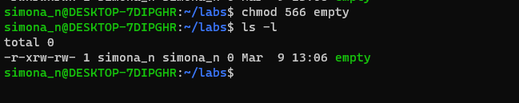

19.Check what owners does the file have.

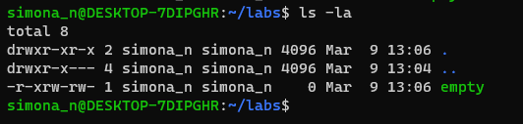

20.Change the user ownership of the file to another user;

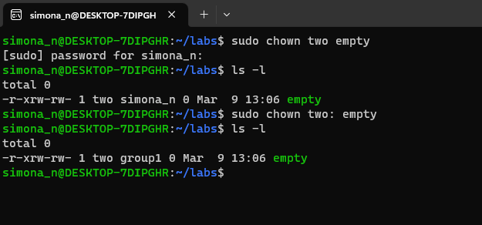

With sudo chown two empty - the group doesn’t change

With sudo chown two: empty – the group is also changed

21.Create a group called group1 and assign two users to the group;

* I named this group “group2” because previously I have created group with name “group1”. I could change it with chgrp command but I think it won’t be a problem

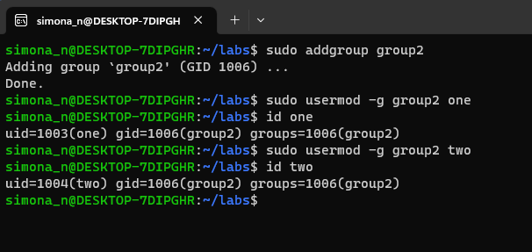

22.Create a file called group1.txt and redirect below input into the file: “This is our group test file”.

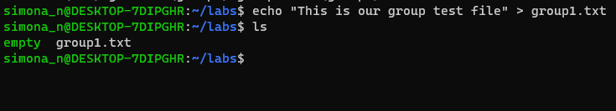

23.Change the group of the file to one of your users;

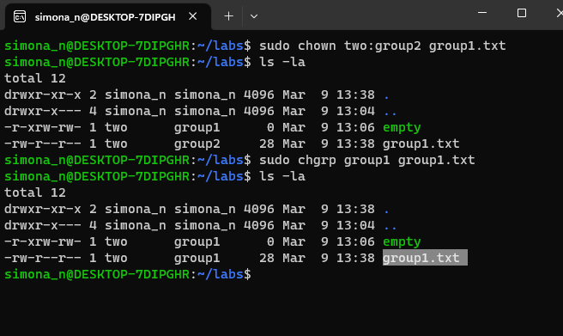

Here I have used two commands. With *sudo chown two:group2 group1.txt* the group of the file is changed to group2

With *sudo chgrp group1 group1.txt* the group of the file is changed to group1

24.Give members of the group group1 read/write access to this file?

